Task 1:Write an SQL query to print the first three characters of  FIRST_NAME from Worker table.

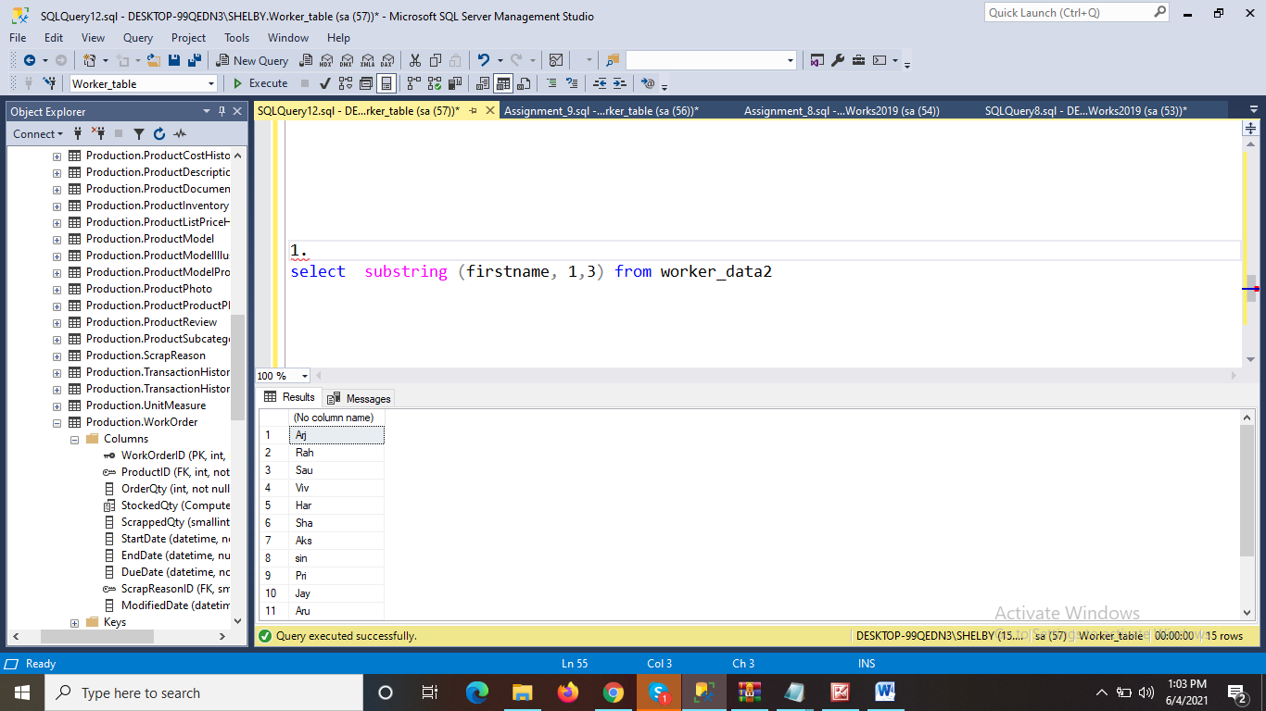

Task 2:

Write an SQL query to find the position of the alphabet (‘a’) in the first name column ‘Amitabh’ from Worker table.

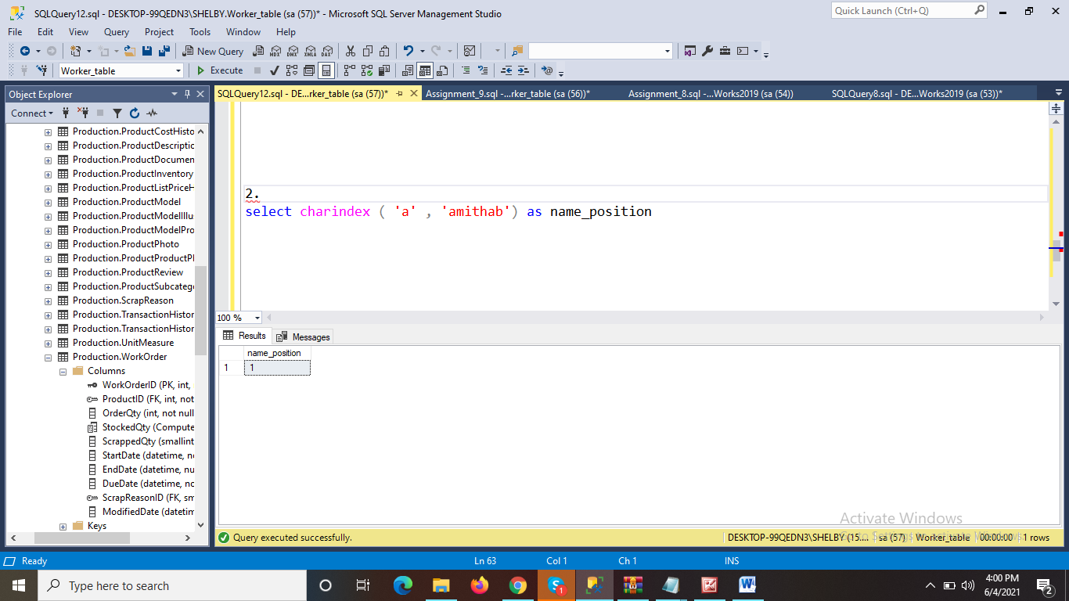

Task 3:

Write an SQL query to print the name of employees having the highest salary in each department.

